# Media Analysis - ChatGPT is the Netscape moment' for artificial intelligence'

## Short Summary

The article portrays ChatGPT as a 'Netscape moment' for AI, emphasizing its conversational prowess powered by LLMs, while highlighting the limitations in understanding, common sense, and reasoning, potentially leading to misinformation and harm.

## Summary

1. **ChatGPT's Impact**: ChatGPT has generated significant excitement, comparable to Netscape making the World Wide Web real in its time. It is a Large Language Model (LLM) built on unsupervised learning, capable of generating responses similar to autocomplete but with broader conversational abilities. 2. **Applications and Benefits**: Global law firms are exploring ways to use ChatGPT for automatic contract creation, while AI-generated content is raising concerns about plagiarism and misinformation. LLMs can be enriched and extended using domain-specific data, offering new value in business applications. 3. **Current Limitations**: Despite their effectiveness, LLMs lack understanding of the world, common sense, and reasoning capabilities, making them prone to generating false or misleading information through "hallucinations". 4. **Future Evolution**: AI will continue to evolve rapidly with advancements in foundation models that can be trained once and reused broadly at minimal marginal cost. These models leverage rules of physics or ethics, bridging the gap between machine-generated text and human thought processes. 5. **Role as a Tool**: LLMs can assist humans in near-instantaneous tasks like object recognition or sentence parsing, while also enabling conscious and logical decision-making that surpasses their current capabilities. 6. **AI's Impact on Labor Markets**: As labor costs rise due to inflationary pressures and a rapidly aging population, AI can increase productivity by automating tasks previously performed by humans. This could lead to both deflation in specific sectors and overall economic sustainability for developed nations like Saudi Arabia. 7. **Saudi Arabia's Advantage**: With a strong emphasis on data-driven AI, extensive efforts to train local talent, and significant investments from national champions like Aramco in developing regional AI capabilities, the Kingdom is well-positioned to capitalize on these opportunities. The localization of LLMs to regional languages and dialects, combined with leveraging domain knowledge, can further enhance Saudi Arabia's competitive edge in AI adoption.

## Question 1:

How do the media in this article frame the public discussion about ChatGPT? Are there certain **metaphors** that keep cropping up?

The media in this text frames the public discussion about ChatGPT using metaphors such as 'Netscape moment' describing its impact like Netscape did for the World Wide Web , 'Large Language Model LLM ' comparing them to autocomplete on steroids , 'AI and panicked university officials' depicting ethical concerns about AI tools enabling misinformation , and 'generative AI tools will enable...highly plausible misinformation' emphasizing potential dangers . These metaphors help frame the discussion as transformative yet potentially problematic.

## Question 2:

Which role does or might the Arabic World play in the development of Artificial Intelligence? Answer with 'Not mentioned' if not applicable.

Not mentioned

## Question 3:

Which use cases of Artificial Intelligence are helpful for the Arabic world based on this article?

1. Legal and contractual automation ChatGPT-like models help automate creating contract skeletons in law firms, reducing reliance on legal staff. 2. Emergence of foundation models Foundation models can be trained once and extended for specific industries or regions, like the energy sector in Saudi Arabia.

## Question 4:

What is the final message of the article that the author wants to convey? Keep your answer short and precise!

The author emphasizes that AI's transformative power should be harnessed alongside augmentation with human-like reasoning, knowledge, and ethical understanding. The article underscores the need to address ChatGPT's current limitations and integrate these advanced models into systems capable of conscious decision-making.

## Sentiment

The sentiment is <0>

The sentiment towards AI in this article is mixed, balancing both the potential benefits and limitations of Large Language Models (LLMs) such as ChatGPT.

## Entities

Chatgpt, Technologist Investment Program, Saudi Arabia Develop Country Face Demographic Challenge, Saudi Public Private Sector Entity Encourage Explore Technology Create New Value Respective Field Industry, Anthony Butler, Focus Application Artificial Intelligence Blockchain Metaverse Technology Large

## Topic Clusters

### Cluster: AI Ethics & Society Impact

Unsupervised Learning, Word Understanding, Reasoning Limitations, Plagiarism Prevention, Misinformation Generation

### Cluster: Advancements in AI Technology

ChatGPT, Domain-Specific Learning, Foundation Models

### Cluster: Societal Changes due to AI

Demographic Shifts

## Word Clouds

### Wordcloud of content

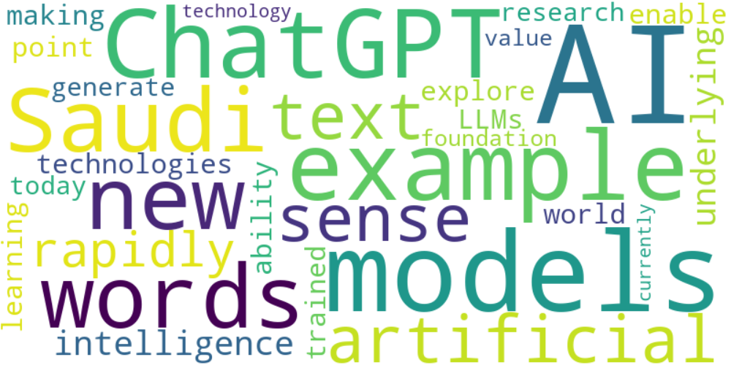

Top 10 words:

- AI: 13  
- models: 8  
- ChatGPT: 6  
- example: 6  
- new: 5  
- words: 5  
- Saudi: 5  
- artificial: 4  
- text: 4  
- sense: 4

### Wordcloud of summary

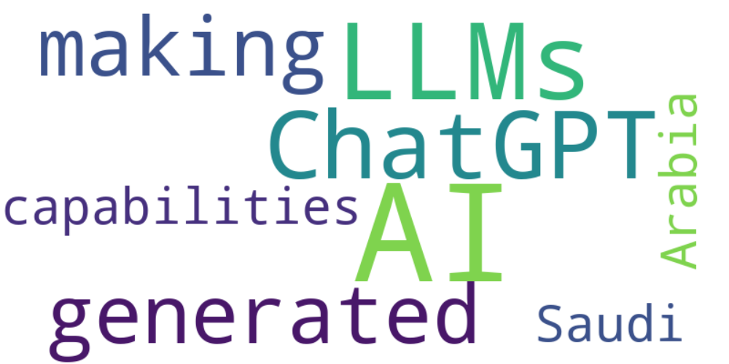

Top 10 words:

- AI: 7  
- LLMs: 4  
- ChatGPT: 3  
- generated: 3  
- making: 3  
- capabilities: 3  
- like: 3  
- Saudi: 3  
- Arabia: 3